Use Cases

for

CarLife

Version 1.0 approved

Prepared by SAMMY

Nanyang Technological University

18th August 2022

Revision History

|  |  |  |  |
| --- | --- | --- | --- |
| **Name** | **Date** | **Reason For Changes** | **Version** |
|  |  |  |  |
|  |  |  |  |

Use Case Diagram

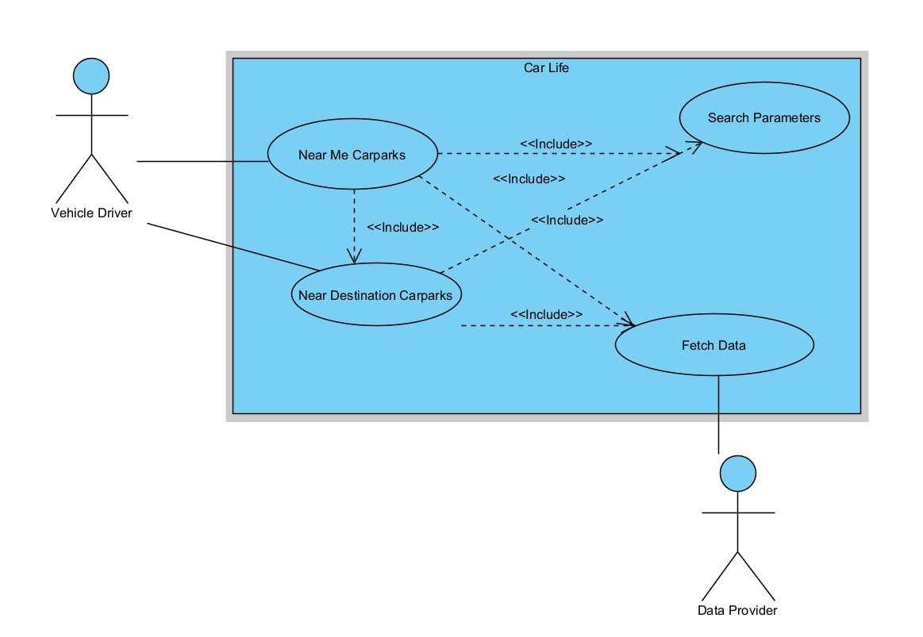

Use Cases

|  |  |  |  |  |
| --- | --- | --- | --- | --- |
| Use Case ID: | 0.1 | | | |
| Use Case Name: | Input Search Parameters | | | |
| Created By: | Aaron | | Last Updated By: | Aaron |
| Date Created: | 24/08/22 | | Date Last Updated: | 24/08/22 |
| Actor: | | Initiating Actor: NULL Participating Actor: User | | |
| Description: | | The user will input personal search parameters and have the parameters verified as valid data | | |
| Preconditions: | | The user must be able to access the application | | |
| Postconditions: | | The validated search parameters will be returned to the calling use case | | |
| Priority: | | High priority | | |
| Frequency of Use: | | Every Journey | | |
| Flow of Events: | | 1. User will open the application 2. User will be prompted to allow the system to use their current location 3. The system will retrieve the current location from the user’s device 4. User will be prompted to key in additional search parameters 5. The system will verify that the inputs are valid and return the inputs to the calling use case | | |
| Alternative Flows: | | 0.1.AF.1  If the user denies the system access to their current location, the system will display a modal with the message “We were not able to process your request as you have denied access to your current location.” and an acknowledgement “Ok” button to make remove the modal  0.1.AF2  If the calling use case is Use Case 1.2, the system will suggest predicted travel location based on the user’s current text input.  0.1.AF.3  If user input is invalid, the system will change the border color of the relevant input field to red and display a message under the input field element that states the error. The input field will revert back only when the user input becomes valid | | |
| Exceptions: | | - | | |
| Includes: | | - | | |
| Special Requirements: | | - | | |
| Assumptions: | | - | | |
| Notes and Issues: | | - | | |

|  |  |  |  |  |
| --- | --- | --- | --- | --- |
| Use Case ID: | 0.2 | | | |
| Use Case Name: | Fetch Data | | | |
| Created By: | Aaron | | Last Updated By: | Aaron |
| Date Created: | 24/08/22 | | Date Last Updated: | 24/08/22 |
| Actor: | | Initiating Actor: NULL Participating Actor: User | | |
| Description: | | The system will send GET requests to the APIs of the Data Providers to retrieve the data required for processing the user’s request | | |
| Preconditions: | | 1. The Input Search Parameters use case must have correctly validated the user data | | |
| Postconditions: | | 1. The use case that called this use case must receive the data in an appropriate format | | |
| Priority: | | High priority | | |
| Frequency of Use: | | Every Journey | | |
| Flow of Events: | | 1. The system issues GET requests to the Data Providers, with the request queries based on the user-defined search parameters 2. The system awaits responses 3. Data Providers receive the request and return appropriate response 4. The system verifies that all requests have a status code of 200 5. The system consolidates the data received from all the calls into a single data object to be returned to the use case that called it | | |
| Alternative Flows: | | .2.AF.1  The system will timeout after 15s and return whatever available data it has to the use case that called this use case | | |
| Exceptions: | | 0.2.EX.1  If one or more of the requests time out or the corresponding response contains an error status code, the system will still pass the available data back to the calling use case, but also return a status code that some data was not obtained  0.2.EX.2  If all the requests time out or all the corresponding response contains an error status code, the system will return a status code that none of the data was obtained | | |
| Includes: | | - | | |
| Special Requirements: | | - | | |
| Assumptions: | | The keys in the data returned by the Data Providers will not change over time | | |
| Notes and Issues: | | - | | |

|  |  |  |  |  |  |
| --- | --- | --- | --- | --- | --- |
| Use Case ID: | 1.1 | | | | |
| Use Case Name: | Find Carpark Near User Current Destination | | | | |
| Created By: | Marc | | Last Updated By: | | Marc |
| Date Created: | 24/08/22 | | Date Last Updated: | | 24/08/22 |
| Actor: | | User (Vehicle Driver) | | | |
| Description: | | The user will be able to search for the most suitable carpark around current location, and the app will output 10 recommended carparks for the user to use. | | | |
| Preconditions: | | Backend must successfully receive the Search Parameters (0.1) and correct data from data providers in the Fetch Data (0.2) use cases. | | | |
| Postconditions: | | The app must output a list in an appropriate fixed format to the frontend. | | | |
| Priority: | | High priority | | | |
| Frequency of Use: | | Every Journey | | | |
| Flow of Events: | | Actor   1. The user must select the Find Carpark Near User Current Destination use case      1. The user must receive a list of 10 recommended carparks from the app. | | System (App)   1. The app must have received the data gathered through the Search Parameters (0.1). 2. The app must issue a request to the backend with user-provided search parameters. 3. The backend must issue an API call using Fetch Data (0.2). 4. The backend must retrieve carpark pricing data from the database. 5. The backend must perform the computation on all carparks to generate a list of 10 recommended carparks based on user-provided input parameters. 6. The backend must sort the list of recommended carparks based on suitability matrix | |
| Alternative Flows: | | 1.1.AF.1  If the user selected difficulty in mobility through 0.1, the backend must add an additional filter based on carpark type, limiting the results to only "surface car park”.  1.1.AF.2  If the intended destination is forecasted to rain during the duration of visit, obtaining data from data.gov (0.2), the backend shall add an additional prompt to user based on carpark type to only “sheltered  1.1.AF.3  If the intended destination is within 200m of an ongoing event from obtained data from STB Tourism Information and Services Hub (0.2), the backend shall return the event and carpark as a data object  1.1.AF.4  If the user selected an electric vehicle as a vehicular type in 0.1, the backend shall include the nearest two carparks equipped with electric chargers as part of the list of carparks. | | | |
| Exceptions: | | - | | | |
| Includes: | | Search Parameters (0.1)  Fetch Data (0.2) | | | |
| Special Requirements: | | - | | | |
| Assumptions: | | Fixed pricing database unchanged | | | |
| Notes and Issues: | | - | | | |

|  |  |  |  |  |  |
| --- | --- | --- | --- | --- | --- |
| Use Case ID: | 1.2 | | | | |
| Use Case Name: | Find Carpark Near User Travel Destination | | | | |
| Created By: | Aaron | | Last Updated By: | | Marc |
| Date Created: | 24/08/22 | | Date Last Updated: | | 26/08/22 |
| Actor: | | User | | | |
| Description: | | The user will be able to search for the most suitable carpark around their travel destination, and the app will output a list of10 recommended carparks for the user to use. | | | |
| Preconditions: | | The Input Search Parameters use case must have correctly validated the user data | | | |
| Postconditions: | | The use case that called this use case must receive the data in an appropriate format | | | |
| Priority: | | High priority | | | |
| Frequency of Use: | | Every Journey | | | |
| Flow of Events: | | Actor   1. The user must select the Find Carpark Near User Travel Destination use case 2. The user must receive a list of at least 3 recommended carparks from the app. | | System (App)   1. The app must have received the data gathered through the Search Parameters (0.1). 2. The app must issue a request to the backend with user-provided search parameters. 3. The backend must issue an API call using Fetch Data (0.2). 4. The backend must retrieve carpark pricing data from the database. 5. The backend must perform the computation on all carparks to generate a list of 10 recommended carparks based on user-provided input parameters. | |
| Alternative Flows: | | 1.2.AF.1  If the user selected difficulty in mobility through (0.1), the backend must add an additional filter based on carpark type, limiting the results to only "surface car park”.  1.2.AF.2  If the intended destination is forecasted to rain during the duration of visit, obtaining data from data.gov (0.2), the backend shall add an additional prompt to user based on carpark type to only “sheltered carparks”.  1.2.AF.3  If the intended destination is within the vicinity of an ongoing event from obtained data from STB Tourism Information and Services Hub (0.2), the backend shall return the event details as a user prompt.  1.2.AF.4  If the user selected an electric vehicle as a vehicular type in (0.1), the backend shall include the nearest two carparks equipped with electric chargers as part of the list of carparks. | | | |
| Exceptions: | | - | | | |
| Includes: | | Search Parameters (0.1)  Fetch Data (0.2) | | | |
| Special Requirements: | | - | | | |
| Assumptions: | | Fixed pricing database unchanged | | | |
| Notes and Issues: | | - | | | |